PIZZA SALES SQL QUERIES
A. KPI’s
1. Total Revenue:
select round(sum(total_price),2) Revevue from Pizza_sales
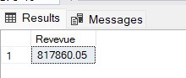
2. Average Order Value
select concat('$',round(sum(total_price)/count(distinct order_id),2)) from Pizza_sales
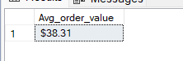
3. Total Pizzas Sold
SELECT SUM(quantity) AS Total_pizza_sold FROM pizza_sales
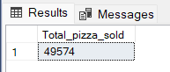
4. Total Orders
SELECT COUNT(DISTINCT order_id) AS Total_Orders FROM pizza_sales
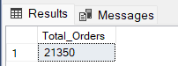
5. Average Pizzas Per Order
select sum(quantity)/count(distinct order_id) as Average_Pizzas_per_order from Pizza_sales
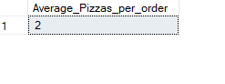
B. Daily Trend for Total Orders
select DateName(WEEKDAY,order_date) as weekday,Datepart(weekday,order_date) Day_no,Count(distinct order_id) No_orders from Pizza_sales
group by DateName(WEEKDAY,order_date),Datepart(weekday,order_date)
order by Datepart(weekday,order_date)
Output:
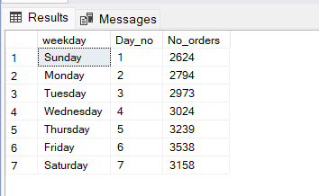
C. Monthly Trend for Orders
select Datepart(HOUR,order_time)as time,count(distinct order_id) No_orders from Pizza_sales
group by Datepart(HOUR,order_time)
order by Datepart(HOUR,order_time)
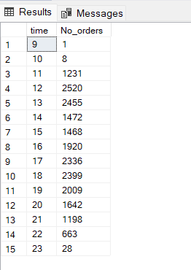

D. % of Sales by Pizza Category
select pizza_category,sum(total_price) total_sales,
concat(round(sum(total_price)*100/(select sum(total_price) from Pizza_sales),2),'%') percentage
from Pizza_sales
group by pizza_categoryOutput
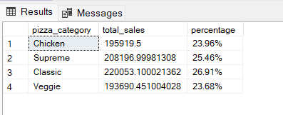
E. % of Sales by Pizza Size
select pizza_size,sum(total_price) total_sales,
concat(round(sum(total_price)*100/(select sum(total_price) from Pizza_sales),2),'%') percentage
from Pizza_sales
group by pizza_sizeOutput
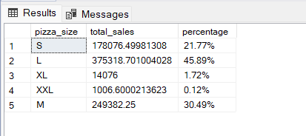

F. Total Pizzas Sold by Pizza Category

SELECT pizza_category, SUM(quantity) as Total_Quantity_Sold
FROM pizza_sales
GROUP BY pizza_category
ORDER BY Total_Quantity_Sold DESCOutput
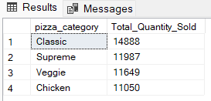

G. Top 5 Pizzas by Quantity
SELECT Top 5 pizza_name, SUM(quantity) AS Total_Pizza_Sold
FROM pizza_sales
GROUP BY pizza_name
ORDER BY Total_Pizza_Sold DESC
Output
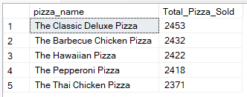
H. Bottom 5 Pizzas by Quantity
SELECT TOP 5 pizza_name, SUM(quantity) AS Total_Pizza_Sold
FROM pizza_sales
GROUP BY pizza_name
ORDER BY Total_Pizza_Sold ASC
Output
